**TABLE T5 DISTRIBUTOR**

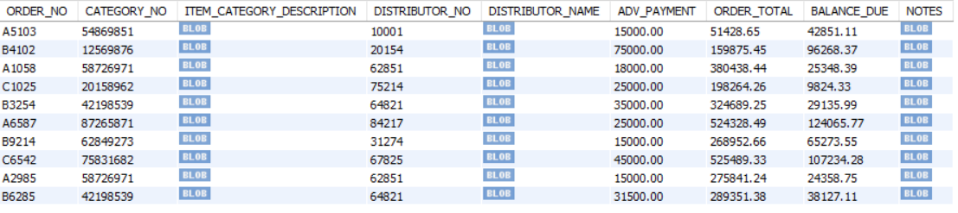

**TABLE T4 PRODUCTS AND SUPPLIER**

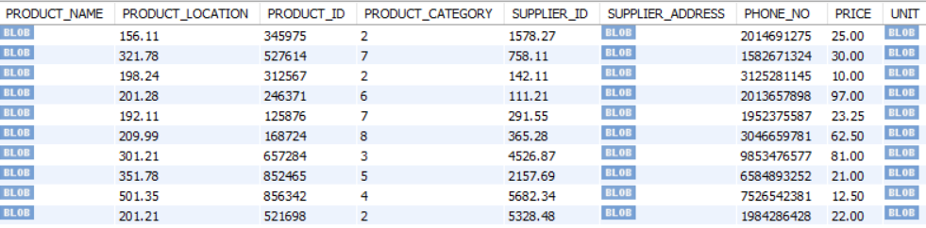

**TABLE T6 DAILY REGISTER**

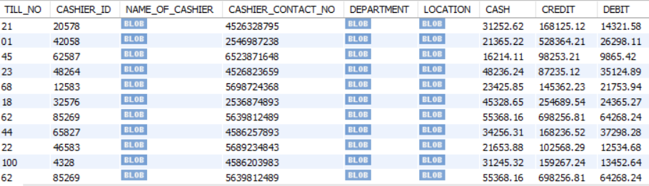

**TABLE T9 POSTAL VOTING DATA**

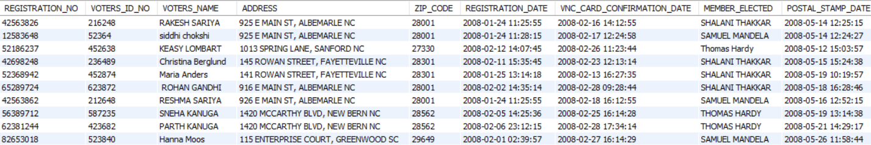

**TABLE T10 ELECTRONIC VISA**

